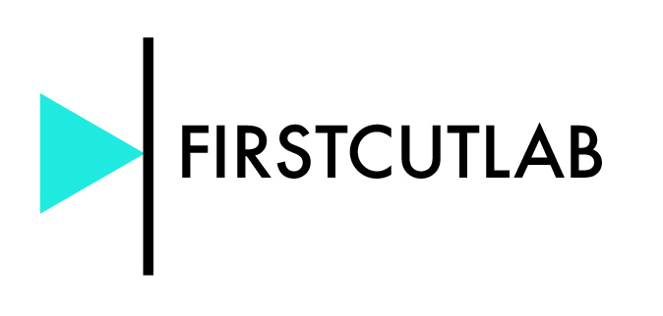
APPLICATION FORM
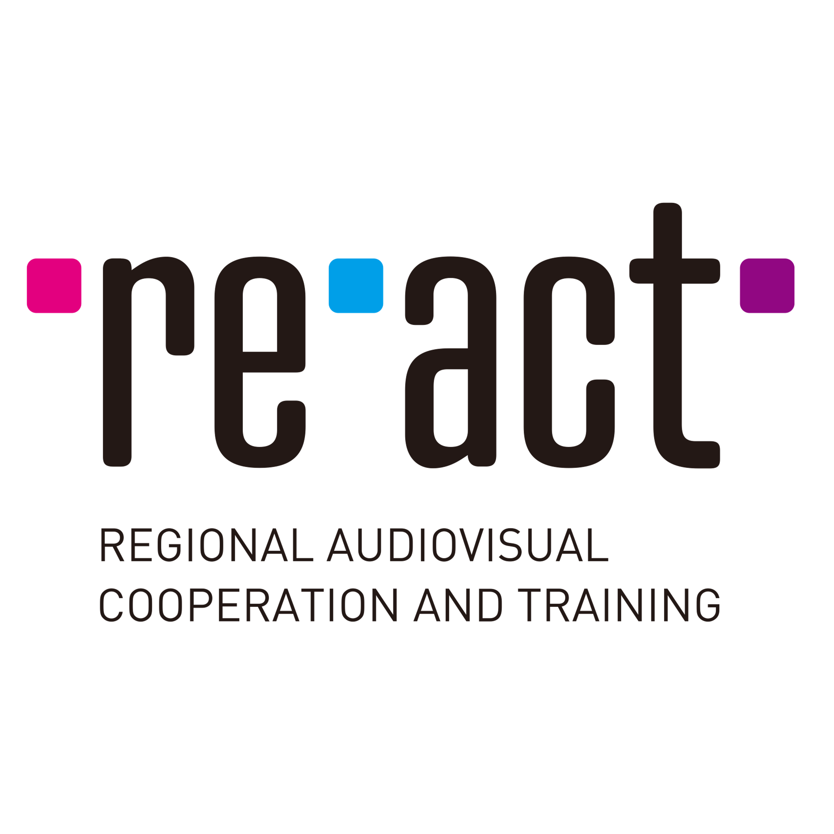
First Cut Lab RE-ACT 2023

Applications must be sent to :
julie.marnay@firstcutlab.eu

1. Film Info

English title:
Original title:
Countries of production:
Planned release date:
Genre:
Planned running time: min. sec.
Language(s):
Director (name/surname/email):
Writer (name/surname/email):
Editor (name/surname/email):
Current post-production phase: (selected scenes/first assembly/rough cut/final cut)
Estimated delivery date:
Previously presented at (platforms, workshops, festivals, if applicable.):
Logline:
Long Synopsis (max 2000 characters):
Directors statement (max 2000 characters):

2. Director

First feature/Second feature/Other
Director Biography:
Director Filmography:

3. Producer

Name:
Surname:
Email:
Phone:
Company:
Company website:
Co-producers (countries, companies):
Sales Agent (if attached):

4. Video material

Length of submitted material:
Type of submitted material: full-cut/selected scenes
Viewing Link:
Password:

Please note that the video is mandatory to be available via streaming service password
protected (e.g. Vimeo).

5. Motivation

Description of the material and concerns regarding the current edit:
Aims for the workshop:
Preferred period for the Lab (please indicate 2 consecutive weeks within the period October 2, 2023 – March 29, 2024):

